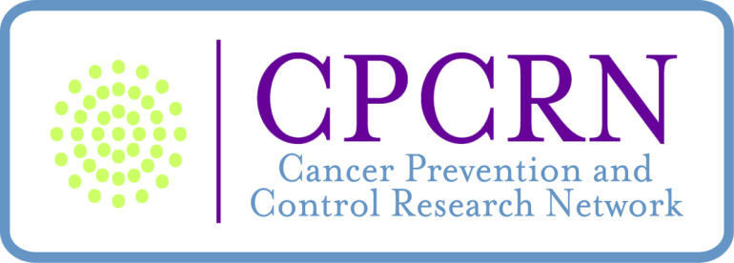

Policies and Procedures
Approved 3/22/2012 at Steering Committee Meeting
Updated Affiliate Policy 1-17-14

Elements of a Vision for CPCRN 2
CPCRN Logic Model 3
CPCRN Funder Expectations 4
CPCRN Progress Reporting: Overview of Reporting Obligations 5
Steering Committee Roles and Responsibilities 8
Coordinating Center Roles and Responsibilities 9
CPCRN Workgroup Policy 10
Publications Policy 11
CPCRN Marketing Plan 13
CPCRN CDC IRB and Publications Clearance Policy 14
Affiliate Member Policy 16

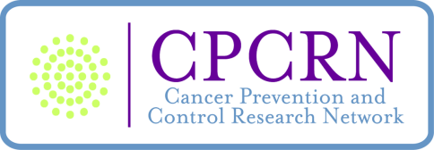

Elements of a Vision for CPCRN

Mission: To advance the field of dissemination and implementation (D & I) research, accelerate adoption of evidence-based approaches to cancer prevention and control, and to align practice, research, and policy to improve delivery of services across the cancer care continuum.

Working together, the ten member centers of the CPCRN, the Coordinating Center, and the federal funding partners (CDC and NCI) are advancing the science and practice of cancer prevention and control in ways that transcend efforts by each individual Center. Each Center brings unique and complementary expertise, as well as access to diverse study populations in a wide variety of geographical settings. Collectively and individually, CPCRN has established an extensive infrastructure of collaborative research and practice partnerships across community organizations, governmental agencies, and academic/research institutions. This combination of skills, expertise and collaboration enables us to rapidly respond to enduring and emerging cancer control needs with a focus on practical implementation, dissemination, and community-engaged research.

Priority Areas:
- Enhance large-scale efforts to reach, engage, and provide service to underserved populations with the aim of building community capacity to reduce cancer disparities

- Identify, develop, and apply rigorous research methods for studying D & I processes

- Contribute to and use theory-based models; assess their utility in guiding D & I efforts across diverse settings, populations, and conditions

- Develop and promote the use of theory-based, standardized metrics for measuring D & I processes and outcomes

- Generate and synthesize research findings to guide practice and policy decisions

- Improve information exchange between practitioners and investigators across all phases of the research continuum (i.e., discovery to dissemination)

- Create and advance community partnerships for D & I processes.

CPCRN Logic Model
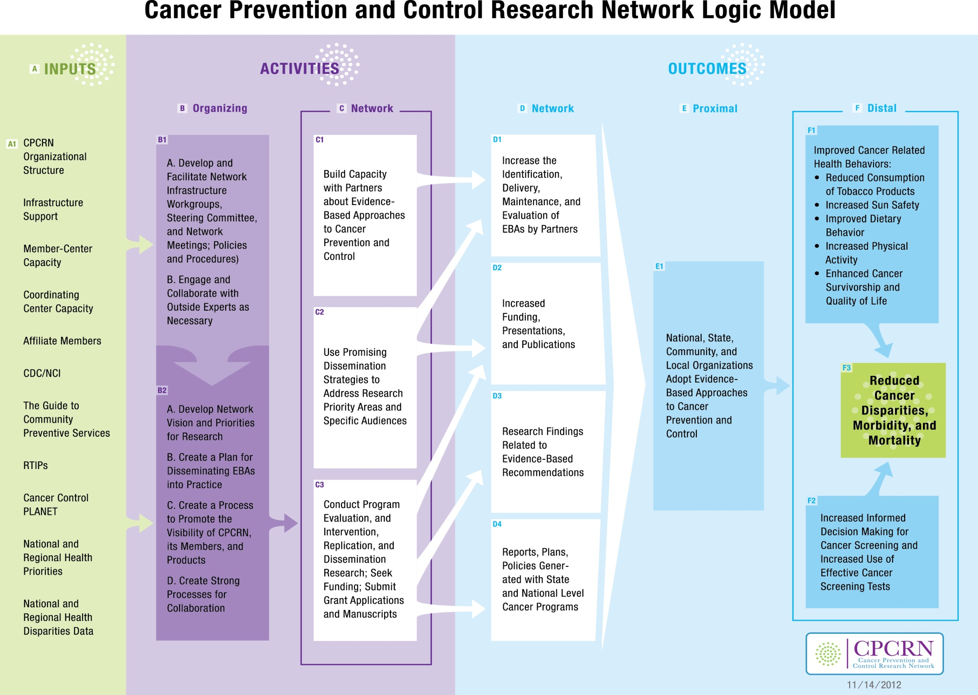

CPCRN Funder Expectations

- Promoting and documenting CPCRN progress, visibility, and penetration
- Complete and approve Marketing Plan.
- Affiliate Members – have completed Affiliate Member policy and link this policy with the Marketing Plan.
- Conduct at least 2 presentations annually on CPCRN, including CDC and NCI presentations.
- Have one paper or a major symposium (e.g., highlighted panel or coordinated papers) accepted per year on activities of the full CPCRN. Suggested conferences are the CDC Cancer Conference when offered and at least one other not attended in the previous year.

- Scientific productivity of CPCRN overall
- Conduct and report dissemination and implementation science that exemplifies partnership and action research, for example by making a difference in peoples’ lives, improving quality of life, reducing health disparities, and/or supporting and furthering the missions of collaborating social service/public health organizations.
- Serve as ambassadors for and educators on D&I research science, new developments, etc., to one’s home institutions (e.g., CPCRN collaborating centers, CTSA, other partners local or groups) as appropriate to state or region.

- Productivity Expectations for ALL Workgroups which involve at least 3 centers
  - Produce and update bi-annually for distribution to Centers and Funders a two-page Progress Report description of workgroup efforts, partners, and products anticipated in the next six months, including a contact for more information. If there is no proposed activity, include plans for closing the workgroup, including distribution of products.
  - Develop and update a work plan bi-annually for the next year. This will be part of the bi-annual Progress Reporting.
  - Publish at least one paper per year on the progress and contribution to D&I; for example on workgroup formation, partnership building process, methods, outcomes. This paper should be described in the December Progress Report of each year.
  - Apply for grants until funded for cross-center projects.
  - Conduct and provide documentation on D&I projects that reduce health disparities.

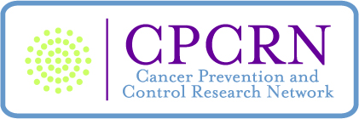

CPCRN Progress Reporting: Overview of Reporting Obligations

This document outlines CPCRN’s progress reporting obligations, developed by the Coordinating Center through extensive work with the Network Centers and Funders to vet their needs and concerns, with approval from the Steering Committee.

There are three distinct levels of reporting within the network, which are described in more detail below, and which we hope will capture the work of CPCRN in the coming years in a useful manner to better inform future research and funding decisions.

There are two progress reporting periods each year. The first is 9/30 – 3/29, with the report being due 6/15. The second is 3/30 – 9/29, with the report being due 12/15.

- Individual Network Center reporting
  - Network Centers will use the CPCRN online progress reporting tool at http://cpcrn.org/progresstool/ to submit twice yearly progress reports, which have been greatly streamlined to reduce the burden of reporting and collect only information that will be used by the funders. Past revisions to this system are described elsewhere in a document titled “CPCRN Progress Reporting Revisions to Individual Network Center Reporting.”
        - The purpose of the progress reporting system is not solely to report on outcomes, but to report on what your center has been doing during the reporting period, with CDC/NCI's funds and those funding sources leveraged or enhanced by the CPCRN infrastructure. Whether you have reportable outcomes or not, you can report on the research activities in which your center is engaging.
        - One of the primary ways that the funders use the progress reporting data for is to show the value added of funding this research network, of showing what we can accomplish together that we might not without the funding, infrastructure, resources, and colleagues provided by the Network. The data in the reporting system helps our CDC and NCI project officers justify to their divisions the continued funding of the network.
        - The online progress reporting system makes it fairly easy to do tracking and quantitative data analysis of the work being done by the Network, so it is easy not only to see (for example) how many publications were made or grant dollars obtained per center and overall, but on specific research topics.
        - Another way the funders use the online progress reporting data is as a database to query to quickly find out what research is being done within the network on a particular topic. For example, someone at CDC wanted to find out what work was being done on prostate cancer within the network, and by querying the reporting database, the coordinating center was able to provide a detailed list of publications, grants, and research activities related to prostate cancer reported within the time period of interest.
  - Network Centers will submit 2-page narrative summary progress reports each reporting period in MS Word format to summarize what their Center has been doing in the prior reporting period, link together related activities reported in the online Progress Tool, and report on activities not captured by the online Progress Tool. Please do not submit in PDF format, as all reports will eventually be combined into one document for the funders in MS Word.
- Workgroup reporting
  - Workgroup Chairs are responsible for submitting a 1-2 page report (in MS Word format) to the Coordinating Center each reporting period. Please do not submit in PDF format, as all reports will eventually be combined into one document for the funders in MS Word. If a workgroup is closing, submit a final report with plans for closing the workgroup, including distribution of products.
  - Reports will include the following information:
    - Workgroup name
    - Chair/Co-Chair names and Center affiliations
    - Names of participating Network Centers and collaborating organizations
    - Number of meetings via:
      - Phone
      - Face-to-face during Steering Committee meetings
      - Face-to-face outside of Steering Committee meetings
    - Plan of work and products anticipated in the next six months
    - Where group’s work falls on the NCCDPHP Knowledge to Action Framework diagram (viewable at http://www.cpcrn.org/progresstool/popups/ConceptualFramework.html)
    - Accomplishments/progress/work completed in past reporting period, highlighting any D&I projects that reduce health disparities. Note: Funder expectations include publishing at least one paper per year on the progress and contribution to D&I, for example on workgroup formation, partnership building process, methods, or outcomes.
    - Citations for all grants and publications completed in past reporting period, highlighting any Dissemination & Implementation projects that reduce health disparities. The funders expect that cross-center projects will continue applying for grants until funded.
    - Funds expended
- Coordinating Center reporting (with input from Steering Committee Co-Chairs)
The Coordinating Center will submit a report to the Funders each reporting period that will cover the following obligations:
  - Develop and facilitate network infrastructure (Logic model box B1A)
    - Date of annual review of current infrastructure plan
    - Date of annual review of CPCRN policies and procedures
  - Engage outside experts (Logic model box B1B)
    - Name of expert and how or why chosen
    - Date and place
    - Purpose
    - Costs
    - Type of activity conducted
    - Results (materials, products, etc.)
  - Develop Network visions and priorities (Logic model box B2A)
    - Date of annual review of CPCRN Vision
    - Review of CPCRN priorities; for each priority:
      - Date of review
      - Is the priority still relevant?
      - Does the priority need updating?
    - Plan of work, to include:
      - Purpose
      - Objectives
      - Duration
      - Description of activities
  - Promoting the visibility of CPCRN (Logic model box B2C)
    - Create (and annually review) a long term marketing and communications plan
    - List activities for the year, including at least one CPCRN-wide presentation at a significant conference. Examples of other activities include webinars, presentations internal to CDC/NCI, and external presentations to those who may affect funding
    - Evaluation – type, results, lessons learned
    - Recommendations
  - Implement and review strong processes for collaboration (Logic model box B2D)
    - Reporting will include both processes created and actual collaborations
    - For each, the following information will be reported:
      - Purpose of relationship (examples: recruit new investigators or partners to the Network, increase quality and quantity of service delivery program partnerships, support state CCC plan implementation, or cross-CPCRN collaboration)
      - Type of relationship
        - Networking
        - Coordinating
        - Cooperating
        - Collaborating
      - Evaluation – type, results, lessons learned

Steering Committee Roles and Responsibilities

- Steering Committee Co-Chairs
  - Facilitate Steering Committee planning and setting overall strategic direction for the next year, and future years
  - Lead the Steering Committee’s development of network-wide collaborations, and model cross-center collaboration through direct and visible actions
  - Generate and facilitate discussion among PIs and the Coordinating Center to help develop short and long term plans to achieve priority performance indicators
  - Coordinate with funders to clarify expectations and assure that Steering Committee activities are consonant with these expectations
  - Assure that the Steering Committee is adhering to agreed-upon timelines and is accountable in meeting benchmarks
  - Proactively facilitate potential network-wide collaborations and among multiple centers.
- Individual PIs (and designated Co-P.I., where appropriate)
  - Attend and actively participate in Steering Committee planning and discussion to stimulate collaborations
  - Actively participate in at least one cross-center project or workgroup
  - Provide leadership within their own centers, to identify and bring other network faculty resources/talent into the collaboration process as appropriate
- Steering committee as a whole
  - Ensure CPCRN activities are in alignment with the mission, vision, logic model/performance indicators, and funder expectations
  - Annually review the mission of the Network and all other policy documents, and make revisions as needed to ensure the Network will accomplish its goals
  - Stimulate and assure cross-center collaboration to assure the network adds overall value
  - Move forward/participate in discussion of action plans to generate signature CPCRN projects/products
  - Actively participate in workgroups to contribute to specific plans to produce signature projects/products
  - Discuss all potential signature projects, approve final selections and provide feedback in the planning and development of these projects.

Coordinating Center Roles and Responsibilities

- Facilitate function of CPCRN workgroups and Steering Committee
  - Work closely with the Steering Committee and Steering Committee Co-Chairs to ensure CPCRN activities are in alignment with the mission, vision, logic model/performance indicators, and funder expectations
  - Manage conflicts as they arise
  - Schedule and/or obtain call-in numbers for conference calls for workgroups and Steering Committee
  - Post workgroup minutes on the website
  - Provide targeted literature searches for CPCRN workgroups, if requested
  - Other tasks as determined by workgroups

- Meeting planning and facilitation
  - Compile and distribute meeting agendas
  - Select meeting venues (e.g., negotiate with hotel, reserve meeting rooms and blocks of sleeping rooms)
  - Reserve needed audiovisual equipment and coordinate presentations with speakers
  - Record and distribute Steering Committee minutes

- Develop and maintain Network website
  - Maintain current calendar, including workgroup and Steering Committee conference calls, meetings, and events of interest to the Network
  - Post meeting minutes
  - Post funding opportunities
  - Update member directory
  - Post PowerPoint presentations from Network meetings
  - Update workgroup information and membership
  - Maintain automated functions allowing workgroups and the Steering Committee to send emails via the website

- Prepare and help draft documents related to the CPCRN policies and procedures
  - Draft policies and submit to Steering Committee for input and approval
  - Provide other documents as designated by the Steering Committee

- Assist in the implementation of marketing and communications plan for the Network

- Prepare summary documents and presentations about the CPCRN

- Coordinate CPCRN evaluation
  - Evaluate progress of Network via the Progress Reporting System developed in conjunction with the funders and Steering Committee and Project Directors
  - Implement periodic surveys, as requested, to evaluate satisfaction with UNC Coordinating Center and CPCRN functioning.

CPCRN Workgroup Policy

Rules for workgroups:

- Potential workgroup ideas should be presented and discussed with the Steering Committee.
- A workgroup must be focused on one or more specific projects with deliverables (e.g., a grant, a publication, survey development, data collection).
- Leadership for the workgroup must be identified, typically a Chair and Co-Chair from different Network Centers.
- Steering Committee consensus should be developed around priority ideas and the new workgroup must be approved by the Steering Committee.
- All Network members should have the opportunity to participate if they choose.
- Workgroups must be formally established and group objectives set.

Types of workgroups:

A CPCRN Signature Project is a workgroup that is deemed so essential that it is a core activity in which all member Centers are required to participate and have representation.

A CPCRN Cross-Center Project is a workgroup that involves a large-scale and ambitious project that will draw participation from most centers. All Centers should participate in at least one Cross-Center Project.

A workgroup must have at least 2 Centers, but typically a standard CPCRN Workgroup would have involvement of 4-6 Centers. Centers are not obligated to participate in every workgroup.

Publications Policy

- Publication, Presentations, and Website Acknowledgments

All publications and presentations must acknowledge CDC and NCI with the following statement:
  - “This publication [or presentation] was supported by Cooperative Agreement Number __________ from the Centers for Disease Control and Prevention and the National Cancer Institute.” If there are multiple CPCRN Centers involved in the publication, the cooperative agreement number for each member Center should be listed.
  - if one of the co-authors is an employee of NCI or CDC, the following sentence should be added to the acknowledgment: “Its contents are solely the responsibility of the authors and do not necessarily represent the official view of the Centers for Disease Control and Prevention, the National Cancer Institute, the Department of Health and Human Services, or the U.S. Government.”

Furthermore, the main title slide of all CPCRN presentations and homepage of all CPCRN websites must include the above statement AND must include the PRC logo (see below).
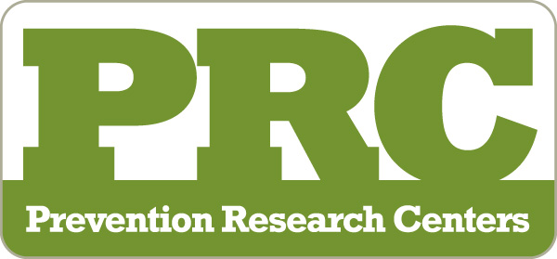

B. Remediation of Authorship Grievances

If there are any conflicts regarding authorship or authorship order on a CPCRN-related paper, the disagreement will be reviewed by the CPCRN Steering Committee. The Steering Committee will discuss the disagreement at an upcoming conference call or meeting. All individuals involved in the dispute will have the opportunity to present to the Steering Committee, which will discuss and ultimately arbitrate the authorship dispute.

Given that the Steering Committee felt that such disputes would be rare, they opted for this approach over establishing a formal Publications and Presentations Committee.

C. Cooperative Agreement Numbers

CPCRN Center | Cooperative Agreement #
Case Western Reserve University | 3 U48 DP005030-01S5
Oregon Health & Science University | 3 U48 DP005006-01S3
University of Iowa | 3 U48 DP005021-01S4
University of Kentucky | 3 U48 DP005014-01S2
University of Pennsylvania | 3 U48 DP005053-01S1
University of S. Carolina- Columbia | 3 U48 DP005000-01S2
University of Washington -Seattle | 3 U48 DP005013-01S1A3
UNC-CH (4CNC) | 3 U48 DP005017-01S8
UNC-CH (CC) | 3 U48 DP005017-01S8

CPCRN Marketing Plan

Goal: The broad goal of the marketing plan is to build awareness of the dissemination and implementation research being conducted by CPCRN, such that we are recognized as being a national leader in this area.
Note: in 2011 there was a Steering Committee discussion about various audiences and an agreement that 1-2 audiences should be prioritized. Although there was no agreement reached at that meeting, the following recommendation is made to focus on the first two, researchers and practitioners.

Audiences/Goals/Suggested Activities
- Audience: Researchers with a focus on dissemination and implementation research, especially for cancer prevention and control
Goal: to advance the science of dissemination and implementation research
Activities:
- 1-2 publications in high impact journals for this audience each year
- 1-2 presentations at professional meetings of targeted groups
- Each year one of the workgroups launches one major webinar on a D&I topic
- Public health practitioners/workforce
Goal: to increase awareness and adoption of evidence-based approaches (EBA) for cancer prevention and control and to increase skills of the public health workforce in assessing the evidence base for a particular issue
Activities:
- CPCRN as a resource for increasing awareness, understanding, use and evaluation of Evidenced-based approaches.
- The CPCRN Capacity Training & Technical Assistance workgroup should offer 1-2 trainings/year to interested groups of practitioners.

CPCRN CDC IRB and Publications Clearance Policy

IRB Clearance

All research involving human participants that involves CDC employees must be cleared not only through the institution/university IRB committee, but also by the CDC IRB. Furthermore, all cross-center projects must obtain CDC IRB approval after obtaining local IRB approval.

This means any study involving multiple Network Centers or a CDC staff member must get CDC IRB approval in addition to local IRB approval.

An exception to this is if the CDC staffer does not obtain data through intervention or interaction, and does not have access to identifiable private information, he/she still can contribute intellectually and serve as co-authors on publishable manuscripts without obtaining CDC IRB approval.

If CDC IRB approval is required, please be sure to allow 3-4 weeks for this process AFTER local IRB approval has been obtained but BEFORE the research is to begin.

The decision to submit to CDC (i.e., Vicki) hinges on whether CDC funds are used for the study. If CDC funds are used in any portion of the study, the protocol must be submitted to CDC (Vicki). In most cases CDC (Vicki) will ask the Human Subjects contact at the National Center for Health Promotion and Disease Prevention (NCCDPHP) for a deferral to the local IRB, which if approved, takes 3-4 weeks time. If the determination is made by the NCCDPHP Human Subjects contact that the protocol needs to be sent to the CDC IRB for full review, it can take up to 3 months. Most protocols submitted under this SIP 09-002 will not need full IRB review, since they are formative research or pilots.

Publication Clearance

All publishable products with CDC staff listed among the authors must receive formal clearance from the agency before publishing. This includes employees of CDC, but does not include employees of other universities/CPCRN Network Centers that receive CDC funding. This means, for example, anything with Vicki Benard listed as an author must go through CDC clearance, but if the authors are limited to Network Center members, CDC clearance is not necessary.

Clearance is to be coordinated by the first-listed CDC author (so, if the publication has several CDC authors, the first listed will coordinate passing the clearance process through CDC).

Products requiring formal clearance include, but are not limited to:
- Manuscripts
- Journal articles
- Book chapters
- Abstracts for meetings
- Website content

The CDC clearance process can take 4-6 weeks, longer when the clearance is more involved (involving review by senior staff, policy issues, cross-clearances, high-profile journals, etc).

The CDC clearance process must happen AFTER a final draft is ready, but BEFORE the draft is submitted to the publishers for review.

When preparing a publication for submission to publishers, authors should leave ample time (at least 4-6 weeks) in between completion of the document and submission to publishers to allow for CDC clearance.

For more information, see: http://cdc.gov/od/science/policies/clearance.htm

Affiliate Member Policy*
Updated 1-17-14

This policy establishes procedures and expectations for individuals and organizations to participate in CPCRN as Affiliate Members. This policy applies to individuals and organizations that wish to participate in CPCRN but are not funded directly by CDC/NCI as CPCRN Centers. CPCRN members include faculty and staff at the PRC-funded centers. Affiliate Members can include, but are not limited to, faculty members, researchers, universities, nonprofit organizations, or community partners who are not currently CPCRN Members.

Eligibility for Affiliate Membership
To be eligible for Affiliate Membership, individuals or organizations must have interest in and capability to contribute to the mission and goals of the CPCRN through participation in a CPCRN workgroup.

Procedure for Becoming an Affiliate Member
1. Nominations:
Individuals seeking to become Affiliate Members must:
- Identify a current CPCRN member who will serve as a sponsor.
- Discuss joining the Workgroup with the sponsor.
- Download and complete the nomination form.
- Send the completed nomination form to the sponsor, who then adds a brief paragraph describing what the applicant will bring to and/or contributes to the workgroup (skillsets, etc.).
- Send a CV to the sponsor.
- Follow up with the sponsor to ensure that he or she forwards the nomination form and CV to the Workgroup Chair.

Note: Individuals who wish to participate in more than one workgroup must complete a separate nomination form for each workgroup.

Organizations seeking to become Affiliate Members must:
- Submit a letter to the Chair of the workgroup in which they wish to participate that describes the mission or purpose of the organization; the expertise, interests, or resources the organization would bring to the workgroup; and the expected role or contribution the organization would make to the workgroup.

Review and Approval Process:

- The Workgroup Chair reviews and approves the nomination and submits it to the Coordinating Center for referral to the Steering Committee.
- The Steering Committee reviews and approves the nomination.
Expectations of Affiliate Members

Affiliate Members are expected to participate actively in a CPCRN workgroup. The specific role and contribution of the Affiliate Member in the workgroup can vary as a function of the workgroup’s activities and the expertise of the Affiliate Member. At a minimum, Affiliate Members must attend two or more workgroup calls or meetings per year and engage in at least one workgroup project or activity.

Benefits of Affiliate Membership

Affiliate Members become listed on the CPCRN website and subscribed to the CPCRN listserv and the and the email lists for the workgroup of interest. Affiliate Members participate in, or even co-lead, efforts to:

- Conduct research
- Develop manuscripts, presentations, tools, or products
- Develop grant applications

Affiliate Members do not become eligible to receive Special Interest Project funding from CDC; however, Affiliate Members can become involved in seeking other project or activity funding when it becomes available or to create opportunities as part of CPCRN.
Workgroups are encouraged to delineate the roles and responsibilities of Affiliate Members in the initial stages of research, projects, manuscripts, grant applications and other activities. Data use agreements, if appropriate, should describe Affiliate Members’ access to and use of data originating from Workgroup research.

Support for Affiliate Members

Affiliate Members may receive funds when available for participating in specific workgroup projects or activities. The Coordinating Center will bear the cost of Affiliate Members’ participation in workgroup or Steering Committee calls; however, the Coordinating Center is unable to cover travel, lodging, transportation, or food costs for Affiliate Members’ participation in CPCRN meetings.

Removal and Reinstatement of Affiliate Membership
Affiliate Members that do not meet these minimum participation requirements will be deemed inactive and removed from the CDC-CPCRN distribution list. Membership can become re-established upon request and with the understanding of active participation.

*Note: This policy is modeled after the Affiliate Member policy developed by the CDC Healthy Aging Research Network and key elements were discussed at the October 2013 annual fall meeting in Denver and a Steering Committee call in December 2013.

